
www.wimetrics.com

WiSentry v3.1
Wireless Access Point Detection System

- 24x7 wireless rogue access point detection
- No wireless hardware required
- Simple install and operation, extremely cost effective
- VLAN Mode (New Feature!)
- Integration with Wired Network Security Systems, Compliance/Audit and Vulnerability Assessment Systems.

Unsecured wireless access point (AP) hardware can be plugged into a corporate wired LAN quickly and easily, potentially bypassing ALL security - including firewalls and IDS/IPS systems. Without a “proactive” security solution to find these rogue AP’s, network administrators will have no notification or warning. WiSentry protects your entire enterprise WIRED network from wireless AP intrusions.

Centralized Monitoring – VLAN Mode
With its scaleable architecture, WiSentry can protect every WIRED network segment simultaneously. Now delivering VLAN Mode – WiSentry can monitor up to (64) distributed VLAN topologies concurrently from a single 802.1Q trunk port. A central WiSentry Control Server can support multiple 802.1Q trunk port connections, delivering the capability to protect even the largest networks from wireless AP intrusions…all from a handful of network points.

WiSentry continuously monitors the WIRED network for unregistered AP hardware and provides network administrators with a comprehensive display showing all AP activity. Wireless AP’s are detected immediately, allowing network administrators to identify and secure or remove them before network security is compromised. User Configurable Alert Events allow administrators to leverage SNMP traps and Syslog events to automate threat remediation. WiSentry also delivers the capability to generate custom reports relating to wireless AP intrusion events.

WiSentry Display
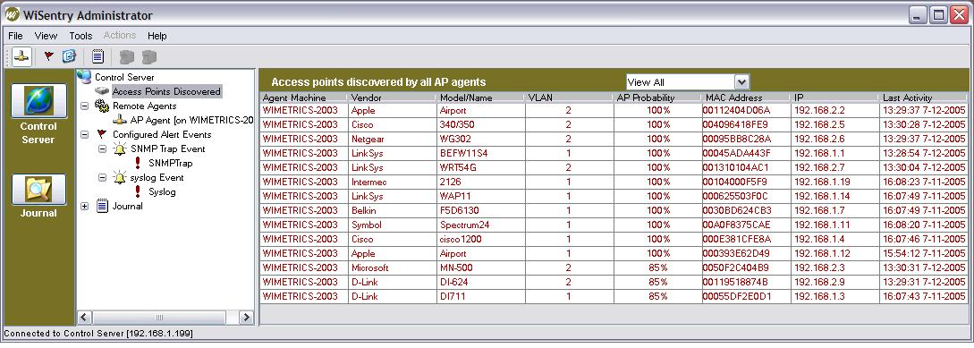

Leverage existing security system investments – extend visibility and protection.
Rogue AP’s introduce open conduits for network intrusions at all levels and are capable of bypassing all layers of security - yet traditional security systems are incapable of detecting their presence. WiSentry is a critical complement to existing security platforms such as IDS/IPS Systems, Firewalls and Malware Filters. WiSentry protects the corporate network from the inside against unauthorized access points that bypass these security systems and policies. Extend the capability of existing corporate security platforms with WiSentry to include Rogue AP Intrusions.

No special hardware required.
In the wireless world, any LAN socket becomes a potential point of intrusion. Comprehensive security requires 100% protection of the distributed wired enterprise network. Some access point detection solutions require the purchase and installation of proprietary wireless hardware devices that scan the RF spectrum. To protect 100% of the enterprise wired network with these RF sensors is most often cost-prohibitive. WiSentry is a complete software system, and requires no expensive 802.11 hardware.

Try it! See for yourself!
WiSentry is available for download and 30-day evaluation for no obligation. Qualified evaluations will be provided with complementary Product Support during the evaluation. Request a free evaluation online at www.wimetrics.com !

WiSentry Core Components.

WiSentry Control Server
The Control Server identifies and stores information on wireless access points. It manages all WiSentry Agents on each LAN segment and monitors the wired LAN for rogue access points.

WiSentry Agent
Located on the wired side of the corporate LAN, Agents operate as Windows Services and continually monitor/probe the network to identify the signatures and anomalous behaviors of wireless access points.

WiSentry Administrator Console
The Administrator Console provides the management interface from a centralized view of all wireless access points on the network. It provides information, such as date and time a wireless access point is detected; displays the Media Access Control (MAC) and IP address of the device; and provides vendor and model information of the identified access points. In addition, WiSentry will display network locations, allowing you to quickly locate and disable intruding devices.
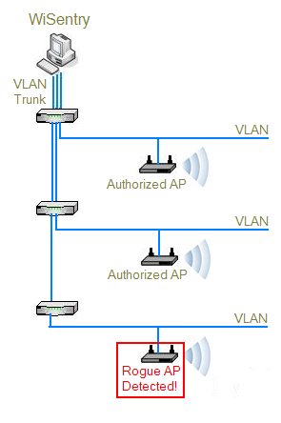
WiSentry System Requirements

Control Server
- Windows 2000 (SP3 or later), Windows XP, or Windows 2003
- PC with 1 GHz or higher, Intel Pentium Compatible
- 512 MB RAM
- 20 GB hard disk
- One network adapter
Agent
- Windows 2000 (SP3 or later), Windows XP, or Windows 2003
- PC with 1 GHz or higher, Intel Pentium Compatible
- 512 MB RAM
- 20GB hard disk
- One network adapter (IntelPro Adapter for VLAN Mode.)
Administrator Console
- Sun Java Runtime Environment 1.4 or higher (included with the product installation)

WiSentry VLAN Topology

1601 114th Ave SE, Suite 120, Bellevue WA 98004 425.637.8999
www.WiMetrics.com
1-877-NoRogue
© 2003 WiMetrics Corporation

